Idea of this project create API what can work from Postman with different types request and showing information from file, and save information to files (requests to Google API and work with S3 files), delete files from S3

Python-Project.ipynb

- Block functions.py
- Block lambda-function.py
- JSON request
- Automatic tests

Test plan.docx - test plan for automatic tests for Block 4 in Python-Project.ipynb

Test AWS.docx - tests with requests in AWS

Test from Postman.docx - tests with requests in Postman

API documentation - https://documenter.getpostman.com/view/32364662/2sA2xe5EUv

Project-backend-only.ipynb - example work for backend only

project.zip - zip-file for download project to AWS

Role in AWS

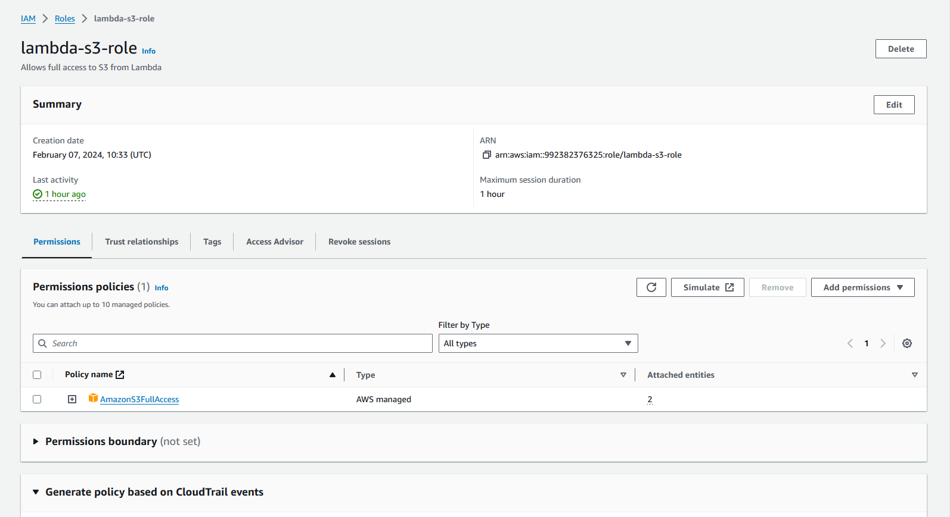
Vulnerabilities and cybersecurity concerns.docx - Cyber Security concerns step-by-step

